Table of Contents
Section I – Introduction 5
1.1. Welcome to Jeng Chi Restaurant 5
1.2. Employee Handbook 5
1.3. Disclaimer, Employment-At-Will & Management Approval Authority 5
1.4. Approval Authority for Position & Pay Changes 6
1.5. Administration and Changes 7
1.6. Interpretation; Deviation; No Past-Practice Rights 7
1.7. Conflicts with Law or Other Documents 8
Section II - Employment Policies 9
2.1 Employee Classifications 9
2.2 Equal Employment Opportunity (EEO) & Americans with Disabilities Act (ADA) 9
2.3 Introductory Period 10
2.4 Required Certifications & Paid Training 11
2.4.1 Food Safety (Food Handler – TXDSHS) 11
2.4.2 Alcohol Service (TABC Seller-Server) 11
2.5 Paid Training – FLSA/TWC Compliance Rules 12
2.6 Parking 12
2.7 Required Notices and Postings 12
Section III - Hours of Work & Payroll Practices 13
3.1 Pay Periods & Paydays (Texas Payday Law) 13
3.2 Workweek & Hours of Work 13
3.3 Timekeeping (All Employees) 18
3.4 Timekeeping: 18
3.5 Record all training time on your timecard. 18
3.6 Timekeeping & Wage Compliance. 19
3.7 Overtime (Nonexempt) 19
3.8 Overtime for Tipped Employees (Servers) 19
3.9 Meal & Rest Breaks 19
3.10 Payroll Deductions (Texas Payday Law) 20
3.11 Uniforms & Work Equipment (Deductions) 20
3.12 Wage Garnishments 21
3.13 Direct Deposit & Lost/Returned Payments 21
3.14 Pay Statements & Access (MyToast) 22
3.15 Payroll Questions & Disputes 28
3.15 Tips & Gratuities Policy (Texas) — Pooling, Credit-Card Tips & Processing Fees 28
3.16 Scheduling & Break Periods Policy 29
Section IV — Standards of Conduct 31
4.1 Zero-Tolerance Policy (Safety, Integrity & Respect) 31
4.2 Anti-Harassment / Anti-Discrimination & Diversity 32
4.3 Diversity & Inclusion Commitment 32
4.4 Examples of Prohibited Conduct (Not Exhaustive) 33
4.5 Speak-Up & Investigation Policy 33
4.6 Our Investigation (What Happens Behind the Scenes) 34
4.7 Anti-Retaliation (Zero Tolerance) 34
4.8 Professional Boundaries & No-Horseplay 34
4.9 Workplace Searches & Monitoring 36
4.10 Personal Cell Phone & Earbud Policy 37
4.11 No Smoking, Vaping, Chewing Gum, Dipping 37
4.12 Personal Errands While on the Clock 38
4.13 Employee Bar Policy 38
4.14 FOH Order Integrity & Guest Service 38
4.15 Dress Code & Uniform Standards 41
4.16 Employee Purchase of Menu Items Policy 43
Section V - Discipline & Corrective Action 44
5.1 Standard Progressive Path 44
5.2 Cross-policy progression (no reset) 44
5.3 Documentation & Timelines 45
5.4 Zero-Tolerance / Immediate-Termination Offenses (Examples) 45
5.5 Attendance & Punctuality – Specific Ladder 45
5.6 Fights, Threats & Workplace Violence 46
5.7 Dishonesty, Theft & Fraud (Your requested rules) 46
5.8 Unprofessional / Disrespectful Conduct (Employees ↔ Managers/Owners) 46
5.9 Social Media & Communications 46
5.10 Drugs, Alcohol & Impairment 47
5.11 Harassment, Discrimination & Retaliation 47
5.12 Corrective Action Plans (CAPs) 47
5.13 FOH: Order Integrity & Guest Service 47
5.14 Benefits & PTO on Separation 49
5.15 Resignation (Two-Weeks’ Notice) & How to Submit 49
5.16 Company Acceptance / Scheduling During Notice 50
5.17 Conduct During Notice (Discipline Still Applies) 50
5.18 Job Abandonment (No-Call/No-Show) 50
VII Family and Medical Leave (FMLA) 51
6.1 Eligibility (FMLA) 51
6.2 Qualifying Reasons (FMLA) 51
6.3 Pregnancy & Childbirth — How FMLA and PWFA/ADA Interact 51
6.4 Amount, Scheduling & Intermittent Leave 52
6.6 Employee Notice Responsibilities 53
6.7 Medical Certification & Fitness-for-Duty 53
6.8 Employer Notices (What You’ll Receive) 53
6.9 Performance, Conduct & Anti-Retaliation 53
6.10 Fraud/Abuse 53
6.11 Concurrent Leaves & Workers’ Compensation 54
6.12 How to Request FMLA or Pregnancy-Related Accommodation 54
6.13 Administration & Questions 54
SECTION IX Doctor’s Notice & Medical Leave Documentation 55
7.1 When a Doctor’s Note Is Required 55
7.2 How to Submit Your Doctor’s Note 56
7.3 FMLA Screening & Paperwork (if/when we are FMLA-covered) 56
7.4 Pregnancy, Childbirth & Related Conditions (PWFA/ADA) 56
7.5 Workers’ Compensation & Work-Injury Notes 57
7.6 Pay, PTO & Scheduling During Medical Leave 57
7.7 If Documentation Is Not Provided (Doctor’s Notes, FMLA Certification, Fitness-for-Duty) 57
7.8 Fitness-for-Duty (FFD) to Return 58
7.9 No Retaliation / Consistent Application 58
Section VIII – Employee Benefits & Services (Overview) 59
8.1 Eligibility & Waiting Period 59
8.2 PTO (Paid Time Off) — Accrual Start 60
8.3 Coordination With Leave & Payroll 60
8.4 Payroll Advance policy 60
8.5 Conditions for requesting a payroll advance 60
8.6 Employee Meal (Unpaid Meal Break) 61
8.7 Worker Compensation Insurance. 62
8.8 Employee Time Off 62
8.9 Use and Management of PTO 63
8.10 Paid Time Off Policy (PTO) 64
8.11 Request to use PTO 64
8.12 Requesting & Scheduling PTO 64
8.13 Pay & FLSA Guardrails 64

Section I – Introduction
Effective Date: January 1, 2026
Version: 2.0

Welcome to Jeng Chi Restaurant
We are pleased to have you join our team here at Jeng Chi. This restaurant has been operating since 1990 and we would like to recognize our employees as our most valuable resource for our continuous success. Our capability in providing customers with authentic Taiwanese food and an enjoyable customers dining experience depends on having high quality people like yourself and your fellow employees. We want you to enjoy your time with us here and we are committed to helping you succeed in your new job opportunity.

Employee Handbook
Purpose and Coverage
This Employee Handbook (“Handbook”) summarizes key personnel policies, benefits, and workplace standards of Jeng Chi Restaurant (the “Company”), 400 N. Greenville Avenue, Suite 11, Richardson, Texas 75081. It applies to all employees and is intended to promote consistent, lawful practices in accordance with guidance from the Texas Workforce Commission (TWC) and applicable federal, state, and local laws. Compliance with this Handbook is a condition of employment.

Disclaimer, Employment-At-Will & Management Approval Authority
Purpose.
This section clarifies the nature of employment at Jeng Chi Restaurant (“The Company”), explains how handbook policies may change, and sets the approval standard for any changes to an employee’s position or pay.
Not a Contract.
This handbook is a general guide to THE COMPANY policies and does not create a contract, guarantee of employment, or promise of specific terms or continued employment. Nothing in this handbook alters the at-will employment relationship, which may be ended by the employee or by THE COMPANY at any time, with or without notice and with or without cause, to the extent permitted by law.

Right to Modify.
THE COMPANY may interpret, revise, suspend, or discontinue any policy, benefit, or practice described in this handbook at any time, with or without notice, except where advance notice is required by law. If there is a conflict between this handbook and an official plan document (for example, insurance plan documents), the official plan document controls.
No Unauthorized Promises.
No supervisor, manager, or employee may make any oral or written promise, agreement, or representation contrary to this section. Only a written agreement signed by Janelle Teng or Francisco Teng may modify the at-will relationship or these approval requirements.
Equal Employment & Non-Retaliation.
All decisions regarding hiring, compensation, scheduling, promotion, demotion, and separation are made based on legitimate business reasons and in compliance with federal, state, and local law. THE COMPANY prohibits unlawful discrimination and retaliation. Employees who raise good-faith concerns or participate in investigations are protected from retaliation.

Approval Authority for Position & Pay Changes
To ensure consistency, internal controls, and legal compliance:
Scope:
The following actions require prior written approval:
Pay changes
Base rate/hourly rate adjustments, salary adjustments, tip-differential changes, bonuses unrelated to formulaic programs, or changes to incentive plans.
Position changes: promotions, demotions, reclassifications (e.g., full-time/part-time status), title changes, and changes in FLSA exemption status.
Work schedule/pay basis changes that may affect overtime eligibility (e.g., moving from salary to hourly, or vice versa).

Authorized Approvers.
Approval must be provided in writing by one of the following:
Janelle Teng, (Owner) or Francisco Teng, (Owner) (Either approver may act; delegation to another leader must be in writing and kept on file.)
Effective Dates. Changes become effective only after written approval and written notice to the employee. Retroactive changes are prohibited unless required to correct an error or ensure legal compliance.
Invalid Changes. Any unapproved promise or change is void and will be corrected. Employees should report concerns to HR.

Administration and Changes
The Company may modify, rescind, delete, or add policies at any time, in its sole discretion, with or without advance notice, consistent with applicable law. Policy updates may be communicated by revised Handbook pages, written memoranda, email, the HR system, or postings on the employee bulletin board. Unless an effective date is stated, changes are effective upon communication. Employees are responsible for reviewing and complying with updated policies.

Interpretation; Deviation; No Past-Practice Rights
The Company retains discretion to interpret and apply this Handbook and, where appropriate, to deviate from stated procedures based on the facts and business needs of a particular situation, consistent with applicable law. No supervisor’s verbal statement, prior practice, or past decision creates a binding rule, promise of continued employment, or contractual right. Nothing in this Handbook requires the Company to use progressive discipline or follow any specific sequence of corrective steps; the Company may proceed directly to any level of discipline, including termination, where warranted by the circumstances and applicable law.
Supersession
This Handbook supersedes and replaces all prior handbooks, policies, and summaries on the same subjects, including the Employee Handbook dated August 2024. To the extent of any conflict between this Handbook and earlier materials, this Handbook controls. (If any policy conflicts with applicable law or an official plan document, the law/plan controls).

Conflicts with Law or Other Documents
If a policy conflicts with applicable law, the law controls, and the policy will be interpreted or modified to comply. If a conflict exists between this Handbook and an official plan document (for example, a group health plan), the plan document controls. If this Handbook is translated, the English version controls in the event of any inconsistency.

Section II - Employment Policies

Employee Classifications
Purpose.
To clarify how we categorize jobs for pay, scheduling, and benefits; and to comply with the Fair Labor Standards Act (FLSA) and Texas law.
Status Types.
- Exempt (salary, not overtime-eligible): Roles that meet FLSA duties and salary basis tests (e.g., certain executive, administrative, or professional positions).
- Nonexempt (hourly, overtime-eligible): Roles that do not meet the FLSA exemption tests. Nonexempt employees must record all hours worked and are paid overtime for hours >40 in a workweek.
- Full-Time: Regularly scheduled 30+ hours per week.
- Part-Time: Regularly scheduled <30 hours per week.
- Temporary/Seasonal: Hired for a defined period or project.
Notes.
- Classification is determined by the Company and may change with role changes.
- All employment remains at-will regardless of classification

Equal Employment Opportunity (EEO) & Americans with Disabilities Act (ADA)
Policy.
We provide equal employment opportunities without regard to protected characteristics (including race, color, religion, sex—including pregnancy—sexual orientation, gender identity, national origin, age, disability, genetic information, marital status, veteran status, or any other status protected by law). This policy applies to all employment actions (recruiting, hiring, scheduling, pay, promotion, training, discipline, and termination). Retaliation for raising good-faith concerns is strictly prohibited.

Reasonable Accommodation
Who may request:
Applicants and employees with disabilities; employees with sincerely held religious beliefs/practices; nursing employees requesting lactation accommodation.
How to request:
Notify your supervisor or HR/Owner at any time (earlier is better). You may be asked for limited documentation to understand needs.
Interactive process:
We will review job essential functions, potential accommodations, and undue hardship.
Decision:
HR/Owner will provide the accommodation granted or explain alternative options/denials in writing.

Introductory Period
The first 60 days of employment are an introductory period to confirm job fit and performance expectations.
- During the period: You’ll receive training, feedback, and any needed coaching.
- Review: At ~60 days, your supervisor evaluates performance and communicates next steps.
- At-will: Completion (or early completion/extension) does not guarantee continued employment or change at-will status.
- Work authorization: On your first day of hire, employees must complete Form I-9 and provide acceptable documentation.

Required Certifications & Paid Training

Food Safety (Food Handler – TXDSHS)
Who needs it:
Any employee who handles food, food-contact surfaces, utensils, or works in food-prep/BOH/FOH areas.
Deadline:
Complete an approved Texas Food Handler course within 30 days of hire.
Company pays the fee:
The Company pays the course/card cost initial.
Scheduling:
A manager will schedule your course on-site. Do not self-enroll without approval
Paid training time:
Time spent attending required Food Handler training is compensable and paid at the Training Rate (defined below).
Proof & renewals:
Provide a copy of your valid card to your Supervisor/HR and notify them 30 days before expiration. Missing or expired credentials may result in removal from food-handling duties until renewed and may lead to discipline.

Alcohol Service (TABC Seller-Server)
Who needs it:
Employees who sell/serve alcohol (servers, bartenders, some FOH). Must be 18+ to serve alcohol in Texas.
Before any alcohol shift:
Maintain a current TABC seller-server certification.
Company pays the fee:
The Company pays the course/exam fee initial.
Scheduling:
A manager will schedule your course (on-site)
Paid training time:
Time spent attending required TABC training is compensable and paid at the Training Rate (defined below).
Proof & renewals:
Provide proof of certification to Supervisor/HR and notify 30 days before expiration. Employees with lapsed certification may be removed from alcohol-service shifts until renewed and may face discipline.

Paid Training – FLSA/TWC Compliance Rules
Training Rate (compensable time):
Required, job-related training time is paid time at a Training Rate equal to at least the applicable minimum wage (federal or Texas, whichever is higher).
For tipped employees, training hours are paid at full minimum wage (no tip credit) because training time does not produce tips.
For non-exempt employees with a regular rate above minimum wage, required training hours may be paid at the Training Rate. If the employee’s total hours in the workweek trigger overtime (over 40), overtime is calculated using the weighted-average (blended) regular rate for that week, per FLSA.

Parking
Employees must park along Greenville Avenue or in designated employee areas past the third statue. Do not park in front of Jeng Chi or other businesses. Spaces nearest the restaurants are reserved for guests. Violations may result in corrective action.

Required Notices and Postings
We post all required federal and Texas workplace notices (e.g., TWC Texas Payday/Unemployment, EEOC “Know Your Rights,” FLSA minimum wage, and Workers’ Compensation status).
- HR/Owner maintains current versions and audits quarterly.
- Managers ensure posters are visible and undamaged.
- Employees should review posted notices and direct questions to management.

Section III - Hours of Work & Payroll Practices

Pay Periods & Paydays (Texas Payday Law)
Pay frequency
The Company pays bi-weekly; payday is every other Friday by direct deposit or check.
Methods
Direct deposit is encouraged; paper checks are available when direct deposit is not used.

Workweek & Hours of Work
Workweek definition:
The Company’s workweek is Sunday 12:00 a.m. through Saturday 11:59 p.m. This fixed workweek is used to calculate overtime.
Scheduling:
Managers schedule based on business needs. Employees are expected to be available for assigned shifts and to arrive fit for duty.
Purpose
This guide provides step-by-step instructions for setting up the Sling Employee Scheduling App on your mobile phone. Sling is the official platform used by Jeng Chi Restaurant to publish schedules, manage shift changes, and communicate scheduling updates.
Step 1: Download the Sling App
iPhone (Apple Devices):
1. Open the App Store
2. Search for “Sling: Employee Scheduling”
3. Tap Install

Android Devices:
1. Open Google Play Store
2. Search for “Sling: Employee Scheduling”
3. Tap Install
Important: Do NOT download Sling TV. The correct app icon says Sling and includes “Work” or “Employee Scheduling.”
Step 2: Create Your Account
1. Open the Sling app
2. Check your email for a Sling invitation. (Admin will need to send you an invitation to join their account. The link in your invitation is the only way to gain access and view the schedules they create).
3. Use the same email address or mobile number you provided to Payroll/HR.
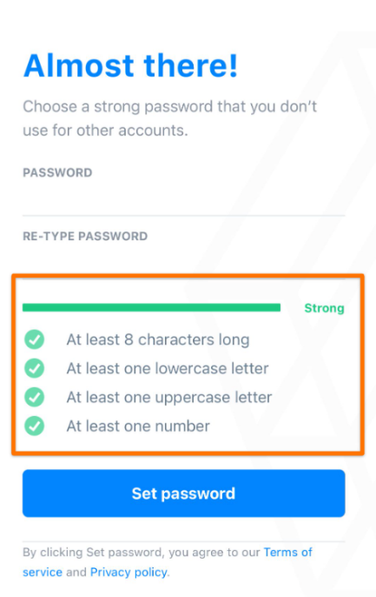
4. Create a strong password.

Step 3: Set Up Your Profile & Availability
- Or go to the More tab in the menu and select Profile from the list to view your profile details.
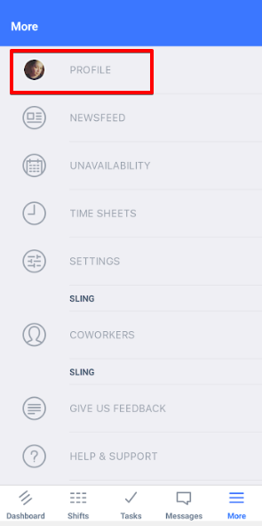

- Next, tap "Edit" in the upper right in order to make changes.
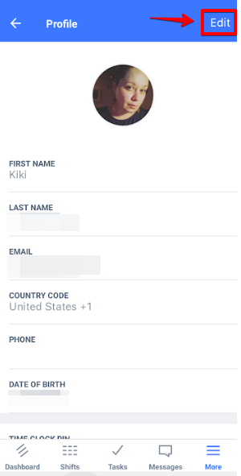

- Then you'll be able to tap on the fields you wish to adjust to make your changes. Again, you will not have access to change certain details that a manager or admin must change.

- Once you've made all the changes you need to, remember to tap Save in the upper right corner before you leave that screen.

Step 4: Turn On Notifications
Inside the Sling App:
- Tap the More tab, then choose Settings from the list.
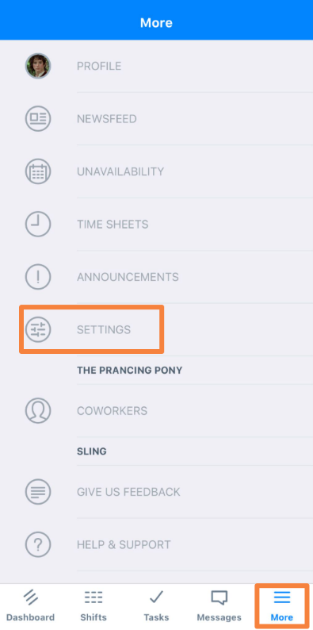

This will bring up a list of options for your notifications. You can switch the toggles to turn an option and/or delivery method on or off. Just like mentioned above, it's a good idea to allow some form of Dashboard notifications so you will be alerted of new schedules and available shifts (among other important info).
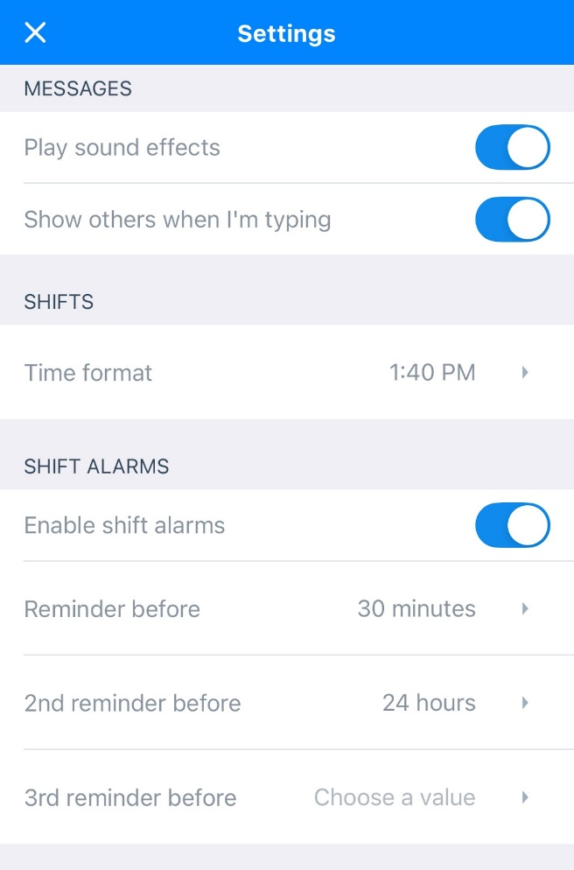
On Your Phone:
• Allow Push Notifications for Sling in your phone’s system settings

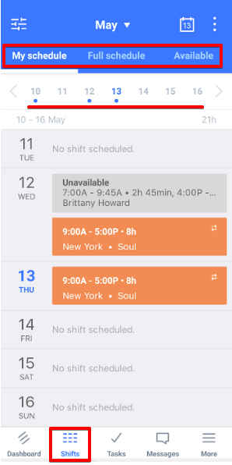
View Your Schedule
1. Tap Schedule
2. Select Week View or Month View
3. Review assigned shifts regularly
4. Accept shifts as required
Important Reminder
Employees are responsible for checking Sling regularly. Schedule updates and changes are communicated through the app. Failure to review or respond does not excuse missed shifts. Off-the-clock work is not allowed Any work performed must be recorded and will be paid.

Timekeeping (All Employees)
Record all time worked:
This includes required meetings, mandatory trainings taken during work hours, and any pre-/post-shift duties.
Missed punch procedure:
If you forget to clock in/out, notify your supervisor the same day.
Clock window.
Do not clock in earlier than 7 minutes before your shift, more than 7 minutes require manager approval.

Timekeeping:

Record all training time on your timecard.
When training occurs:
The Company will schedule required training during work hours or at designated times. If you complete required training at a different time without approval, report the time anyway—it will be paid—and we may address the scheduling issue separately through coaching.

Consequences for non-completion:
Failure to complete required training/renewals on time may result in removal from related duties and/or discipline, up to and including termination, consistent with law and Company policy.

Timekeeping & Wage Compliance.
- Nonexempt & Exempt employees must accurately record all time spent in required training during work hours.
- Training time cannot be taken simultaneously with other duties.
- Nothing in this policy permits pay to fall below applicable minimum wage or to avoid overtime for compensable training hours in a workweek.
- No off-the-clock work. All work must be recorded. Working without recording time is prohibited. If work occurs, it will be paid; policy violations may lead to discipline.

Overtime (Nonexempt)
When owed.
Overtime is paid at 1.5× the regular rate for all hours worked over 40 in a workweek. Only hours actually worked count toward the 40-hour threshold.
Overtime must be approved in advance by a supervisor. If unapproved overtime occurs, it will be paid and may be addressed through coaching or discipline.
Multiple rates
If you work at different rates in the same week, overtime is based on the weighted average (blended) regular rate unless a lawful alternative is used.

Overtime for Tipped Employees (Servers)
Applies to all Server employees. Overtime is paid at $6.13 per hour for all hours worked over 40 in a single workweek. Overtime must be approved in advance by management unless there’s an emergency.

Meal & Rest Breaks
Texas law does not require meal or rest breaks. When the Company provides a meal period, it is unpaid and you must be fully relieved of duty.
Clocking: Non-exempt employees must clock out at the start of an unpaid meal period and clock back in when returning to work. No off-the-clock work.
Location: Eat only in designated employee dining areas. Do not eat in food-prep, service pass, cookline, or dish areas. Wash hands before returning to duty.

Payroll Deductions (Texas Payday Law)
Required by law:
The Company deducts taxes and other legally required amounts (e.g., child support, tax levies).
Employee-authorized:
Any other deduction requires a specific, written authorization that states the purpose and exact dollar amount (no blanket/open-ended authorizations).
Overpayments.
The Company may recover wage overpayments consistent with law; we will notify the employee and may use a reasonable repayment schedule if needed.

Uniforms & Work Equipment (Deductions)
Employees are required to comply with the Company’s established uniform, work shoe (footwear), appearance, and work equipment standards. Unless otherwise required by law, employees are responsible for the full cost of purchase, replacement, and maintenance of all required uniforms, approved work shoes, and authorized work equipment.
Employee-Paid Uniforms
When an employee is required to obtain uniform items and/or required work shoes at their own expense, the following rules apply:
All uniform purchases must be approved in advance by the employee’s Manager.
Manager Approval Required
All uniform and work shoe purchases must be approved in advance by the employee’s Manager.
Company Assistance for Work Shoes
To support workplace safety and compliance, the Company may assist employees by ordering required work shoes through the approved vendor, Shoes For Crews.
- This assistance is for ordering convenience only.
- The employee remains 100% financially responsible for the full cost of the work shoes.
Payroll Deduction Request Process
To request a uniform, work shoe, or work equipment purchase through payroll deduction, the employee must:
- Complete the Uniform Payroll Deduction Authorization Form;
- Clearly identify the specific item(s) being purchased (including uniforms and/or work shoes).
- State the exact dollar amount to be deducted; and Sign and date the authorization.
The completed form must be submitted to the Manager for review and approval before any order is placed or deduction is processed.
Payroll Deduction Requirements
Payroll deductions for uniforms, work shoes, are permitted only when:
- The employee provides written authorization in advance; and
- The authorization complies with the Texas Payday Law.

Wage Garnishments
Upon receipt of a valid court order or agency notice, the Company will withhold wages as directed until the order is satisfied or we receive a formal release Employees should provide documentation if they believe an order is satisfied or incorrect.

Direct Deposit & Lost/Returned Payments
Direct deposit is encouraged but not required Employees using direct deposit must keep bank information current If a direct deposit is returned (closed/incorrect account), the Company will reissue payment on the next regular business day after funds is returned to the Company.
If a replacement is requested due to reasons not caused by the Company (e.g., employee lost or damaged the check, provided wrong banking information, or failed to update a closed account), the Company may assess a $35 processing fee to cover bank stop-payment/administrative costs.
Written authorization required (Texas Payday Law): The fee will only be taken if the employee signs a Payroll Deduction Authorization stating the specific purpose ($35 stop-payment/reissue fee) and exact amount ($35) for that occurrence.

Employee Request Requirement
To request a replacement or reissued paycheck, the employee must:
- Complete the Lost Check Fee Payroll Deduction Authorization Form;
- Acknowledge responsibility for any applicable reissuance or processing fee; and
- Sign and date the authorization form.
No paycheck will be reissued without a properly completed and signed authorization.

Pay Statements & Access (MyToast)
Payroll system of record
The Company uses Toast Payroll (“Toast”) as the Company’s payroll system of record All wages are processed in Toast, and the official pay statement (paystub) for each pay period is generated by Toast.
Access to My Toast
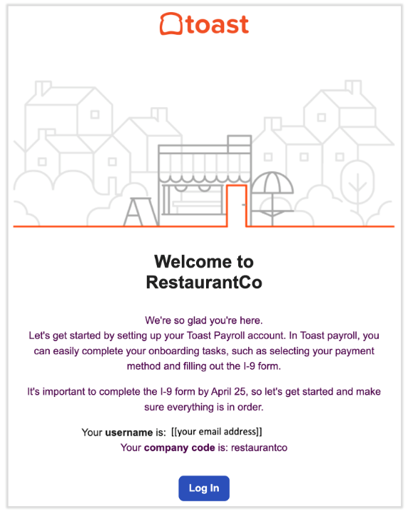
You can begin when you receive the "welcome" email from noreply@toasttab.com. Its subject line is Welcome to the Team! and it contains a link to register for Toast Payroll. Select Log in.
- If you do not see this email right away, check your Spam/Junk folder. Otherwise, your management team can resend the email if necessary.

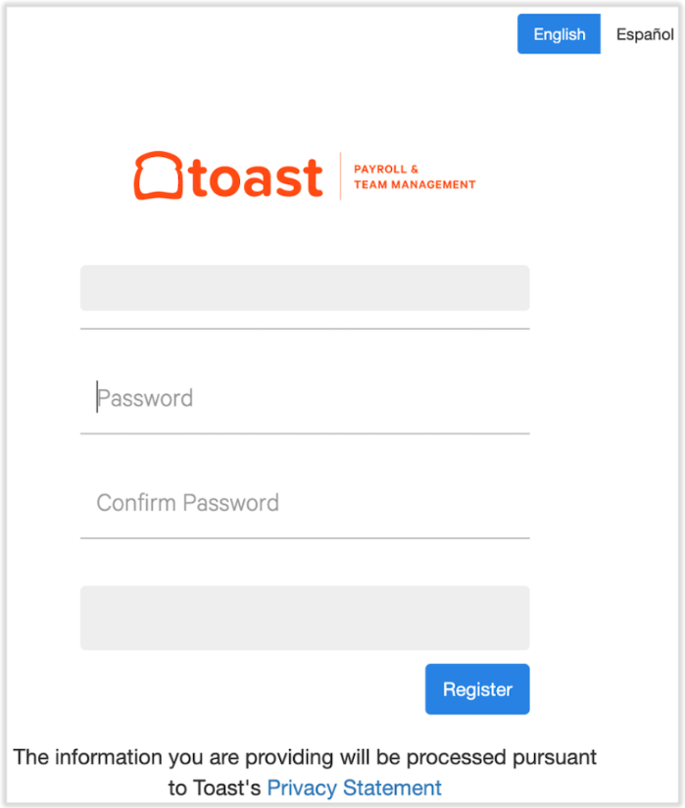
Enter a unique password and confirm it. The password must include one letter, one number, one special character, and must be at least 8 characters long. Select Register and keep this password in a secure location for later use.

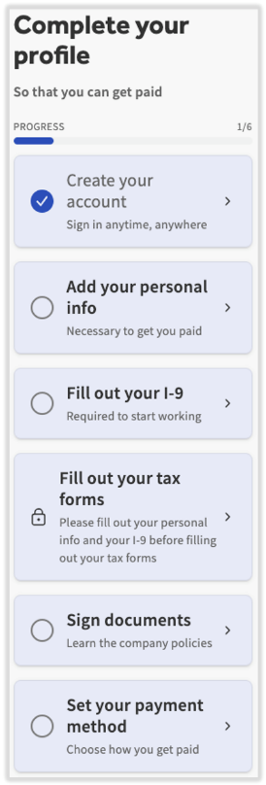
You will now need to complete your profile using the new hire checklist on the main dashboard. These steps must be completed in order to get paid. The Create your account step was completed when you signed in with your credentials. The next step is Add your personal info, so select that tile.
Enter and/or verify your personal information including Date of birth, Contact Info, and Home Address. Select Save Changes to advance.
Add your Social Security Number (SSN). Without an accurate SSN, Toast Payroll may receive errors when attempting to file for a Form W-2.

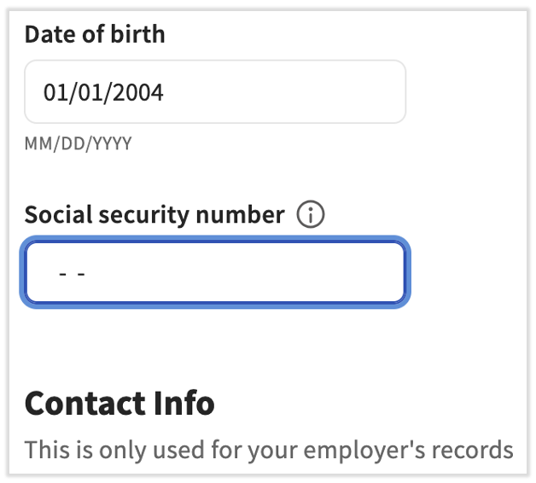

Scroll to the top of the page and select Return to dashboard to continue entering new hire information.
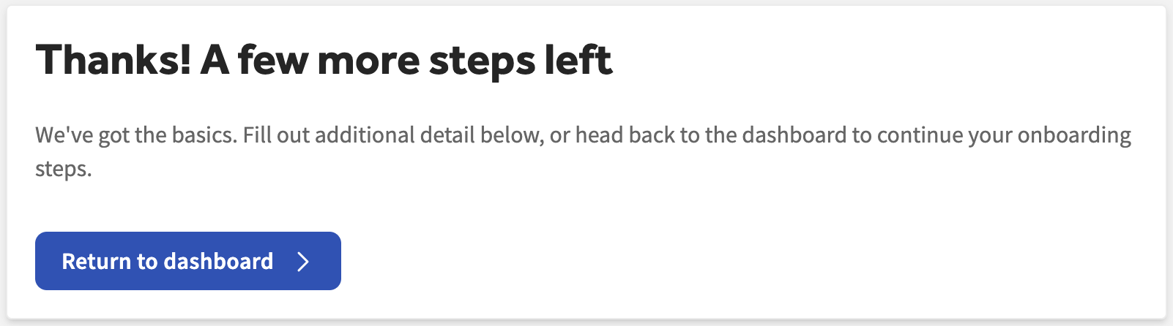
- Now select Fill out your I-9 from the checklist to complete and sign Section 1 of the Form I-9. You must do this no later than the first day of employment. Form I-9 instructions are available at the top of the form in the link. Only employees should fill out or edit their Form I-9. Select Next to continue.
  - Note: If you are unsure of your citizenship or immigration status, do not make a selection until you have confirmation on your status.
- Next, complete your tax information by selecting Fill out your tax forms from the checklist on the dashboard.
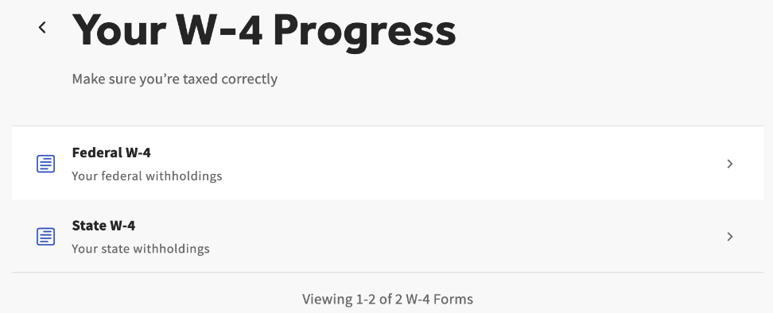
  - Any applicable forms will appear here. Employees must complete federal and state (if applicable) W-4 forms in order to have the proper amount of taxes withheld from their earnings. Toast cannot advise on how to fill out these forms or what information should be entered.
  - Upon completing W-4 information, you will see a page asking you to Return to dashboard to continue with the new hire checklist.

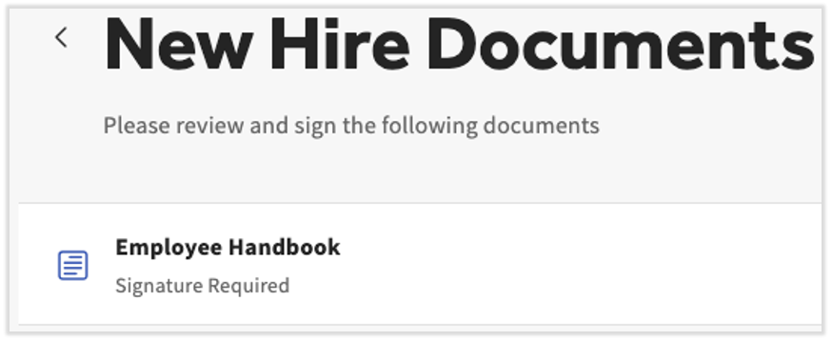
Open the next step by selecting Sign documents. There may be company documents such as an employee handbook or company policies to read and electronically sign, but not all restaurants use company documents. Select Back to Dashboard once these are reviewed and signed, if applicable.

The final step for employees to compete is Set your payment method, so select that tile. Toast Payroll will immediately ask you to login again for your own security purposes.
- If you choose to Set up direct deposit, you will be led through a series of steps by a modal named Plaid. Plaid is an industry leader in bank account validation. To use Plaid, you will need your login credentials to your online bank account.
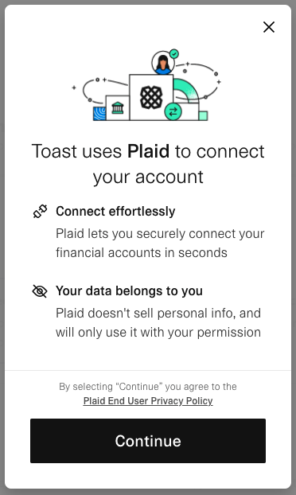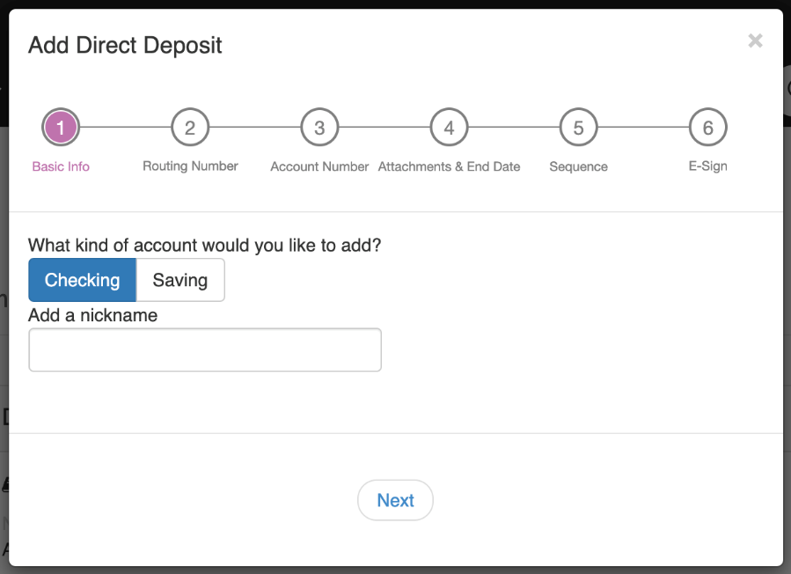
Well done! All steps are complete.

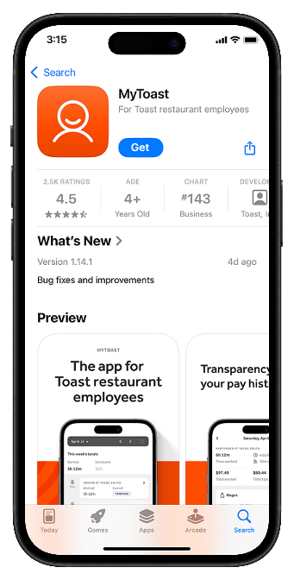
Download the app:
- iOS (App Store): search “MyToast”
- Android (Google Play): search “MyToast”
Make sure the app name is MyToast (not Toast POS).

- Log Into the MyToast App for the First Time
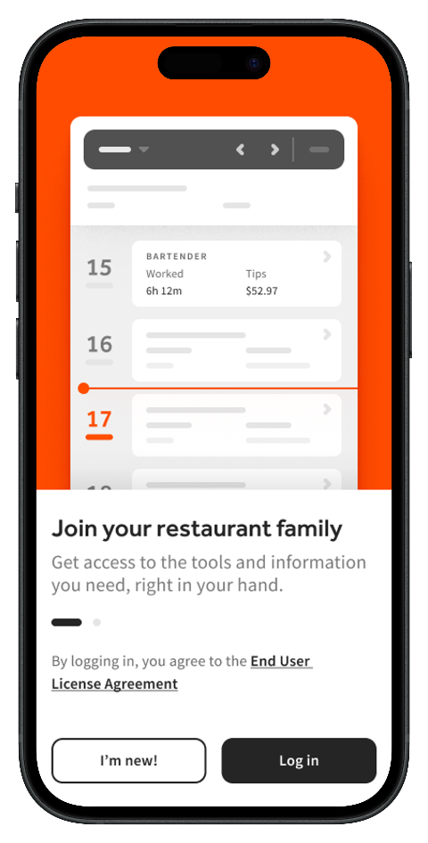
- Log in and use that email and password

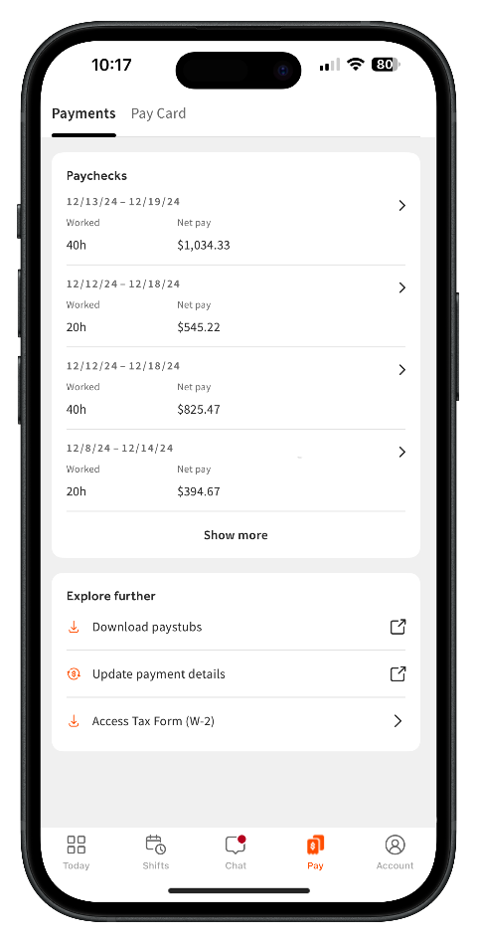
Pay Tab Overview
The Pay tab in the MyToast app allows employees of restaurants that use Toast Payroll to view details related to their wages and tips.
The Paychecks page displays quick information regarding gross and net pay, time worked, earnings, taxes, and deductions. It also links to the Toast Payroll website, where you can download your official pay stubs.
Once a payroll has been run and you've been paid, you can view paycheck details by selecting the Pay tab.
You'll land on the Paychecks page where your paycheck details will be sorted by pay period.
Paycheck details on the MyToast app contain information identical to your paystubs on the Toast Payroll platform.
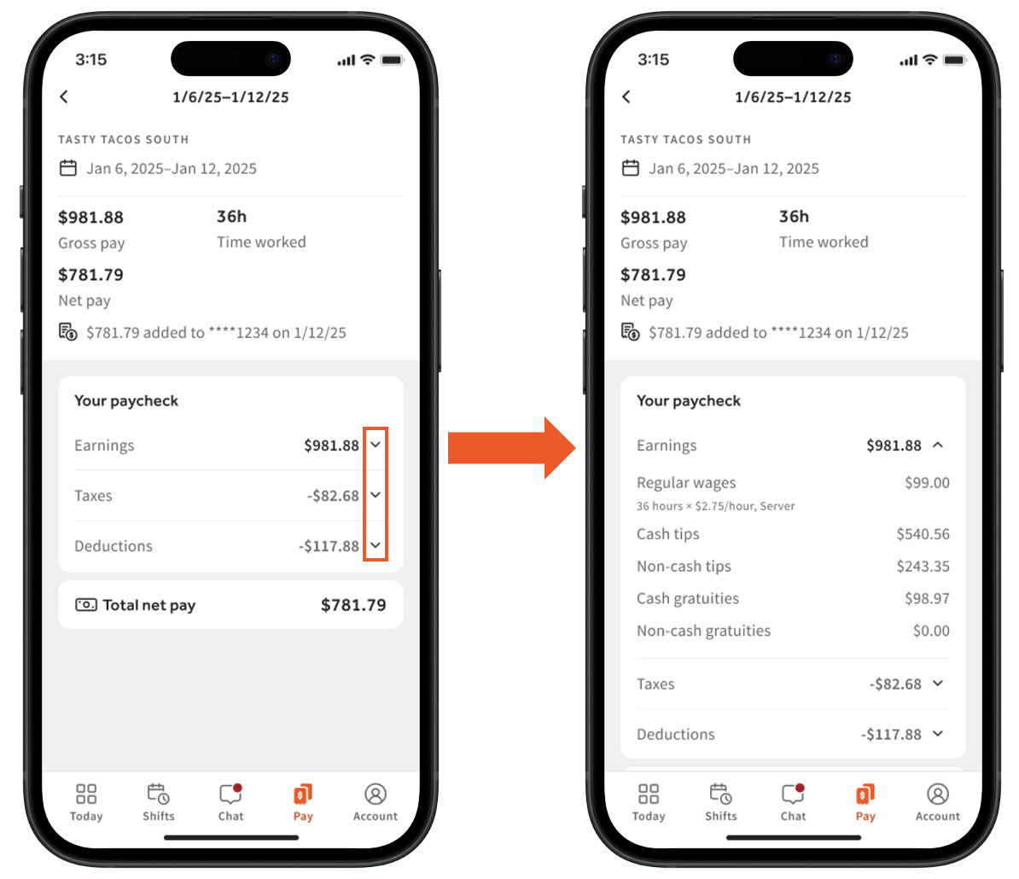
This includes your gross and net pay, hours, earnings, deductions, and taxes.
Select the carat > icon to view a paystub's components.

Final Pay (Separations)
Involuntary separation: (fired/laid off): Final wages are due within 6 calendar days of discharge.
Voluntary resignation: Final wages are due on the next regular payday after the resignation date.
The Company may not hold a final paycheck past the statutory deadline for reasons like unreturned property; if amounts are owed and allowed, we use lawful deductions with written authorization or other lawful means.

Payroll Questions & Disputes
Who to contact:
Report any pay discrepancy to HR/Payroll in writing as soon as you discover it (ideally within 2 business days of payday).
Investigation & correction.
HR will review time records and pay data and respond within 3 business days; any confirmed underpayment will be corrected on the next regular payroll.

3.15 Tips & Gratuities Policy (Texas) — Pooling, Credit-Card Tips & Processing Fees
Scope & Purpose
This policy applies to all tipped and non-tipped employees at Jeng Chi Restaurant (JCR) and governs tips, tip pooling, credit-card tips and associated processing fees, service charges, and required legal notices under federal law (FLSA) and Texas law (Texas Payday Rules).
Definitions
- Tip: A voluntary amount a guest leaves for service. Tips are the employee’s property except as set out in a valid tip pool.
- Credit-Card Tip: A tip left by a guest as part of a payment by credit or debit card.
- Gratuities: The predetermined service charge added to the bill and paid to staff for their service.
- Service Charge: A service charge is a mandatory, predetermined fee added to the guest’s bill by the business.

Core Rules (FLSA/Texas Compliance)
- JCR does not keep employees’ tips or gratuities; Managers and Back of the House are prohibited from keeping any portion of employees’ tips or receiving tips from a tip pool.
- Tip pools will be operated only as allowed by law and this policy, with full and prompt distribution on or before the regular payday for the workweek (or as soon as practicable thereafter if necessary for payroll).

Credit-Card Processing Fees on Tipped Amounts
When a guest leaves a tip on a credit or debit card, JCR may deduct from the employee’s credit/debit card TIP an amount equal to the actual percentage processing fee charged by the card processor on that TIP amount, not to exceed three percent (3%). If the actual processing percentage is lower than 3%, only the lower actual percentage will be deducted.
Tip Pooling / Sharing
JCR may require mandatory tip pooling consistent with federal and Texas law. Managers and Back of the House never participate.
Eligible Roles for Tips
Servers, Bartenders, Bussers, Hosts, Cashiers, Bartender Jr.

Acknowledgment
Employees are required to review, complete, and sign all acknowledgments and any applicable authorizations associated with this policy. These acknowledgments are provided through the Employee Compensation Letter form, which serves as the official record of notice and acceptance.

Scheduling & Break Periods Policy
Work Schedules
As a restaurant operation, work schedules are based on business needs, including guest volume, staffing levels, and operational demands. Schedules may be adjusted at any time to meet these needs.
The Company reserves the right to:
- Adjust start and end times
- Modify assigned shifts or stations
- Reduce or extend hours
- Change schedules with or without advance notice when business conditions require
Employees are expected to remain flexible and comply with scheduling changes as part of restaurant operations.

Break Periods
Break periods in a restaurant setting are not guaranteed at a fixed time and may be delayed, shortened, or adjusted based on business needs, guest flow, and staffing requirements.
Key points regarding breaks:
- Break timing is determined by management and may change without prior notice
- Employees must return promptly when instructed
- Breaks may be delayed or modified during peak service periods
- Breaks are a privilege based on operational feasibility, not a fixed entitlement
Complaints, refusal, or disruptive behavior related to break timing—especially during service or in guest-facing areas—are considered unprofessional conduct.

Section IV — Standards of Conduct

Zero-Tolerance Policy (Safety, Integrity & Respect)
Purpose.
To protect employees, guests, and the business, Jeng Chi Restaurant maintains zero tolerance for conduct that seriously endangers safety, violates law, or undermines trust. This policy applies to employees, managers, owners, contractors, vendors, and guests while on Company time or premises.
What “zero tolerance” means. Reports are acted on immediately; employees may be removed from duty pending review. If facts are confirmed, the Company may proceed directly to final discipline up to and including termination on the first offense, consistent with our investigation process and applicable law. See Speak-Up & Investigation and Anti-Retaliation in Section IV, and 5.4 Zero-Tolerance / Immediate-Termination Offenses for examples.
Zero-tolerance categories (non-exhaustive):
- Unlawful harassment or discrimination based on any protected status; retaliation for reporting or participating in an investigation.
- Violence, threats, intimidation, or weapons on premises.
- Theft, fraud, or serious dishonesty (e.g., stealing cash/merchandise, POS manipulation, falsifying records).
- Serious safety or food-safety endangerment, including willful bypass of critical controls; working while knowingly ill with restricted symptoms; refusing to stop food handling when directed.
- Illicit drugs at work; sale/distribution; on-duty impairment that creates a safety risk; refusal to comply with reasonable safety measures.
- Wage/timekeeping fraud (e.g., off-the-clock work direction or falsification); egregious cash-handling violations.
Mandatory reporting. Report immediately to any Manager on Duty or HR/Owner; you may bypass your supervisor. The Company investigates promptly and as confidentially as practicable. Retaliation is itself a zero-tolerance violation. (See Section IV: Speak-Up/Investigation; Anti-Retaliation.)
Due process & documentation. We will review facts (interviews, POS/camera logs, documents) and decide discipline based on severity, intent, impact, and prior record. Findings and required corrective actions will be documented and shared with the employee.
Management approval & exceptions. Only a written determination by Janelle Teng or Francisco Teng may authorize any exception to this policy, and any exception must remain compliant with law and Company standards.

Anti-Harassment / Anti-Discrimination & Diversity
Policy Statement
Jeng Chi Restaurant prohibits harassment, discrimination, and retaliation based on any status protected by law (for example: race, color, religion, sex—including pregnancy—sexual orientation, gender identity, national origin, age, disability, genetic information, veteran status, and any other status protected by federal, Texas, or local law). We will act promptly and appropriately once we know or should know about a concern.

Diversity & Inclusion Commitment
We value a workforce that reflects many backgrounds and perspectives. We strive to: (1) hire, promote, pay, and schedule based on merit and business needs; (2) build respectful teams; (3) provide reasonable accommodations for disability and religion; and (4) offer fair processes to report and resolve concerns without fear of retaliation.
Definitions (Plain Language)
- Discrimination – An adverse job action (e.g., firing, demotion, pay cut, schedule cut, denial of training) because of a protected status.
- Harassment – Unwelcome conduct based on a protected characteristic that is severe or pervasive enough to create a hostile, intimidating, or offensive work environment, or that unreasonably interferes with an individual’s work performance, or results in an adverse employment action or job-related decision.
- Harassment may be verbal, physical, visual, or written, and includes, but is not limited to, offensive jokes, slurs, epithets, threats, intimidation, ridicule, inappropriate comments, unwanted touching, or the display or distribution of offensive materials.
- Sexual harassment – Unwelcome sexual advances, requests for sexual favors, or other verbal/physical conduct of a sexual nature.
- Retaliation – Any adverse action because someone reported a concern, requested accommodation, or participated in an investigation. Retaliation is strictly prohibited.

Examples of Prohibited Conduct (Not Exhaustive)
- Verbal/Visual: slurs, epithets, insults, demeaning jokes or memes; repeated misgendering; derogatory comments about accent, disability, or religion; displaying offensive images or symbols at work or in work chats.
- Physical: unwanted touching, blocking movement, assault, intimidation.
- Sexual: Unwelcome conduct of a sexual nature, including but not limited to sexual advances, comments about an individual’s body or sex life, lewd or sexually explicit messages, unwanted requests for dates or romantic interaction after a clear refusal, and quid pro quo arrangements, where submission to such conduct is made a condition of employment, scheduling, compensation, or other job-related benefits
- Electronic/Online: texts, DMs, group chats, social media, or collaboration tools that target coworkers or affect the workplace.
- Third Parties: customers, vendors, delivery drivers, or visitors who harass employees. We will intervene and take corrective steps.

Speak-Up & Investigation Policy
Zero tolerance for unlawful harassment, discrimination, sexual harassment or retaliation.
How to report:
Tell any manager, your supervisor, or HR/Owner—you may bypass your supervisor.
Fast response:
We aim to acknowledge within 1 business day and begin review within 1–3 business days.
Confidentiality:
We protect privacy to the extent possible while investigating.
No retaliation:
Protected for reporting in good faith or participating in a review—even if not substantiated.

Our Investigation (What Happens Behind the Scenes)
- Start: Target 1–3 business days after notice.
- Reviewer: HR/Owner (impartial).
- Evidence: Interviews of complainant, respondent, witnesses; collection of documents, chats, schedules, and available video.
- Standard of proof: Preponderance of the evidence (“more likely than not”).
- Corrective actions (as warranted): coaching/training, written or final warning, suspension, removal from guest areas, vendor or third-party restrictions, or termination.
- Closing notice: Complainant receives confirmation the matter was reviewed and addressed.
- Records: Investigation files kept in a restricted HR file and retained at least 1 year (longer if required by law or Company policy).

Anti-Retaliation (Zero Tolerance)
The Company prohibits retaliation against anyone who in good faith reports a concern, asks for accommodation, or participates in a review. Retaliation includes actions that could deter a reasonable person from speaking up (e.g., threats, schedule cuts, undesirable reassignment, isolation). Report suspected retaliation immediately; we will review and correct.

Professional Boundaries & No-Horseplay
Applies to:
All employees, managers.
Purpose:
Maintain a safe, respectful, professional workplace free from harassment, distractions and preventable injuries.
Zero-Tolerance Areas:
Physical contact or behavior that could reasonably make someone uncomfortable, feel unsafe or create a harassment risk is prohibited. Safety-risk behavior (horseplay) is also prohibited. This policy supplements our EEO/Anti-Harassment Policy and Code of Conduct.

Definitions (Plain Language)
- Horseplay: Pranks, roughhousing, running, shoving, tripping, throwing/spraying items, blocking paths/doors, pulling chairs, startling others, or any game-like behavior that distracts from work or creates hazard.
- Unprofessional Physical Contact: Any unnecessary touch not required for the job—e.g., shoulder rubbing, back/neck massage, hugging, tickling, lap-sitting, patting, touching or grooming someone’s hair, braiding, applying makeup, or similar conduct.
- Consent & Power Imbalance: Even if someone says a behavior is “okay,” it may still be unwelcome or coercive when there’s a power imbalance or workplace pressure. “Mutual” behavior can still violate policy if it affects others or the work environment.
- Incidental Job-Related Contact (allowed): Brief, necessary contact to hand items, guide a tray/cart, or render first aid. Keep contact minimal and professional and announce movements (e.g., “behind,” “corner hot”).
Prohibited Conduct (Examples — not exhaustive)
- No horseplay anywhere, especially near hot equipment, knives, fryers/steamers, dish area, storage rooms, or guest areas.
- No touching that isn’t required for work: no shoulder rubbing, massages, hair touching/grooming, hugging, lap-sitting, playful shoving, or similar.
- No pranks or physical jokes (e.g., hiding tools, blocking aisles, flicking towels, spraying water/condiments).
- No body/appearance comments or innuendo; no suggestive or explicit remarks, gestures, images, or sounds.
- No retaliation against anyone who refuses contact, sets a boundary, or reports concerns.
Professional Greetings & Exceptions
- Handshakes/fist-bumps may be appropriate only if clearly welcome and must be brief.
- Job-required contact (e.g., assisting a fall, first aid) is permitted; notify MOD and complete an incident report.
- Cultural greetings should be verbal or non-contact in work areas.
Reporting & Response
- Report to any supervisor/MOD or HR.
- Reports are taken seriously and investigated promptly. We share information only with those who need to know.
- No retaliation: Anyone who retaliates will face corrective action, up to termination.
Consequences
Violations of this policy may result in corrective action up to and including termination. Severity, frequency, intent, impact, and safety risk will guide the response. See Discipline & Corrective Action section below.
Acknowledgment
Employees are required to acknowledge receipt and understanding of the Employee Handbook by completing the Handbook Acknowledgment & Receipt Form. This acknowledgment is completed electronically and applies to all sections and subsections of the Handbook.
Each employee must review the Handbook in its entirety and provide an online signature confirming acknowledgment and understanding of the Company’s policies, procedures, and expectations.
If an employee refuses or fails to sign the electronic acknowledgment, the refusal will be documented, and acknowledgment of receipt may be recorded with a witness signature, as permitted by law. Refusal to sign does not exempt an employee from compliance with the Handbook or its policies.

Workplace Searches & Monitoring
Scope. “Company Property” includes: offices, desks, file drawers, cabinets, lockers issued by the Company, POS systems, Company-owned devices (computers/phones/tablets), email/voicemail/accounts provisioned by the Company, and Company vehicles.
Right to inspect. The Company may inspect Company Property at any time, with or without notice. Employees should not expect privacy in Company Property.
Personal items (on premises). Bags, containers, and personal vehicles on Company premises may be inspected with the employee’s consent were allowed by law.
Electronic monitoring (notice). Company systems (POS, networks, email, business messaging) may be monitored, logged, and reviewed for business, safety, security, and legal compliance. Do not use Company systems for communications you wish to remain private.
Professional and nondiscriminatory. Searches/monitoring will be conducted professionally and without discrimination or retaliation. Any direction to maintain confidentiality will be narrow and time-limited (for example, during an active investigation to protect evidence/witnesses).
Cooperation. Employees must cooperate in inspections of Company Property. Refusal is insubordination and may lead to discipline up to termination

Personal Cell Phone & Earbud Policy
Purpose. Maintain guest focus, safety, and productivity; prevent injuries and food-safety risks.
Baseline rules.
- Phones silent/out of sight while working. Personal use limited to authorized breaks or manager-approved urgent matters.
- No earbuds/headphones in guest areas and Back of House. Exceptions only for a work-approved task/training away from hazards and with manager approval.
- Prohibited during work: personal calls/chats, social media browsing, gaming, studying/reading for non-work purposes.
- Allowed for work: business calls, urgent Company messages, productivity apps as assigned.
Safety. Never use a phone while walking in BOH, carrying hot items/knives, or operating equipment. Observe no-phone zones as posted.
Emergencies. Brief personal calls for emergencies are allowed with manager awareness and away from guest/food-prep areas.
Enforcement. Progressive discipline up to termination.

No Smoking, Vaping, Chewing Gum, Dipping
Covered products. Cigarettes, e-cigarettes/vapes, cigars, pipes, smokeless tobacco, gum and similar products.
Where prohibited. No use inside or within the posted distance of entrances/exits and guest areas.
Designated area. Use only the designated outdoor spot, out of guest sight, during authorized breaks. Wash hands before returning to duty.
Smoke break limit. One brief smoke break per shift may be permitted at manager discretion and must not interfere with operations. Wash hands before returning to duty.
Local rules control. Where local ordinances or landlord rules are stricter, those rules control.
Enforcement. Progressive discipline up to termination.

Personal Errands While on the Clock
Not permitted. Personal errands are not allowed on Company time. For urgent matters, request manager approval to clock out and leave.
Company errands. Tasks like grocery runs, storage trips, DCCC, mailbox or bank drops require manager authorization; you must be on the clock and follow timekeeping rules (no off-the-clock work). Follow any cash-handling/chain-of-custody SOP

Employee Bar Policy
- Must be 18+ to work behind the bar; 21+ to consume alcohol (off duty).
- On duty: absolutely no alcohol.
- Off duty: employees may patronize the bar only if off shift, 21+, out of uniform, and not interfering with operations; limit 2 employees as customers at a time; manager may refuse service.
- All alcohol service must comply with TABC rules and Company ID/over-service SOPs.

FOH Order Integrity & Guest Service
(Applies to: Servers, Bartenders, Hosts, Cashiers)
Purpose & Scope
The purpose of this policy is to maintain 100% accuracy, honesty, and accountability in all front-of-house (FOH) transactions and guest interactions. This includes ordering, charging, packing, and collecting payment across all service channels—including dine-in, bar, to-go, phone, and online orders—while ensuring fair guest assignment and non-discriminatory service at all times.
Core Duties by Role
Servers & Bartenders
- Ring every item into the POS before serving or delivering to a guest.
- Verify age and valid identification for all alcohol service.
- Actively monitor open tabs and follow all close-out procedures.
- Confirm payment is completed before leaving the service area or transferring responsibility.
Hosts
- Seat guests strictly according to approved rotation rules.
- Clearly communicate any section or rotation changes.
- Do not reassign or transfer guests without Manager on Duty (MOD) approval.
- Assist with to-go order staging when assigned.
Cashiers
- Verify order accuracy and correct payment method before closing checks.
- Match receipts to orders and payments.
- Secure and safeguard cash, cards, and gift cards at all times.
- Close all checks accurately and promptly.
Managers on Duty (MOD)
Managers are responsible for enforcing order integrity and guest service standards, including:
- Enforcing ring-before-serve / ring-before-pack requirements; immediately halt service for any un-rung items until corrected.
- Maintaining fair seating rotation and approving all table transfers or reassignments.
- Approving comps, voids, discounts, and price edits in the POS with a required reason code and written note (no verbal or retroactive approvals).
- Investigating and addressing anomalies during the same shift.
- Issuing tills, authorizing paid-outs, securing deposits, reconciling drawers, and addressing overages or shortages immediately.
- Enforcing packing checklists and assigning second-person verification for large or high-risk orders (initials or stickers required when applicable).
- Supporting alcohol service decisions, including borderline ID verification and documentation of incidents.
- Ensuring allergen prompts are followed and personally confirming high-risk allergen orders.
- Coaching employees on the floor and assigning targeted retraining after errors, with manager sign-off.
- Leading incident response for walk-outs or suspected fraud, including:
  - Preserving evidence
  - Reviewing POS data and camera footage
  - Determining next steps (e.g., voids, reports, or law enforcement when appropriate)
  - Documenting actions in the incident log and briefing the next manager
- Escalating discipline for repeated integrity violations in accordance with Company policy and documenting outcomes.
Daily Controls (Managers & FOH)
- POS Integrity: No free items unless properly applied through a manager-approved promotion in the POS.
- Required Reports Each Shift: Open checks, comps/discounts, voids, re-fires, price edits, and cash over/short reports must be reviewed and investigated.
- Packing Accuracy: Use the approved packing checklist; require second-person verification for large or high-risk orders.
- Retraining Triggers: A pattern of mis-rings, missed payments, or packing errors will result in targeted retraining, refresher assessment, and manager sign-off.
Prohibited Conduct (Examples)
- Failing to ring items; serving without a POS entry; unapproved comps/discounts/voids; holding open checks to avoid payment.
- Cash handling violations (shorting, “borrowing,” not securing cash drawer); manipulating tips or tip lines; altering receipts.
- Bypassing packing checks; ignoring second-verification on large orders.
- Transferring tables without approval; re-assigning to steer guests or for personal advantage.
- Dishonesty in any audit/investigation.

Core Expectations
- Ring before serve/pack. Every item must be entered in POS; no “free” items unless a manager-approved promo is applied in POS.
- Payment verification. Follow the Company close-out process and confirm payment before moving on.
- Accuracy controls. Use packing checklists and request second-person verification for large/high-risk orders.
- Cash & records. Secure cash/cards, match receipts, and follow ID/age checks.
- No unapproved changes. Comps/discounts/voids require manager approval.
Payment Verification & “Walk-Outs”
- Negligence (definition). Handing a payment device to a guest and leaving without timely verification, or failing to follow the Company’s close-out procedure.
- If a guest leaves without paying:
  - Notify the Manager on Duty immediately (do not pursue guests).
  - Preserve evidence: note table, time, guest description; retain the check; identify witnesses.
  - Manager reviews camera footage and POS logs and determines next steps (e.g., voids, police report if appropriate).

Dress Code & Uniform Standards
Back-of-House (BOH), Dishwashers, Line Cooks, Wok Chefs, Prep Cooks, Pastry Chefs, Dumpling Makers, Noodle Makers.
- Solid black jeans or dark blue jean or Chef Pants, no caps. Not allowed: rips/holes, heavy fading, baggy or excessively tight fits, leggings/jeggings, yoga pants, sweatpants, shorts, or capris.
- Solid plain top with no logos/graphics (short or long sleeve). May be worn under the chef coat; undershirts must be solid black/white/gray with no visible branding.
- Closed-toe, closed-heel, slip-resistant, non-absorbent shoes. No canvas slip-ons, open backs, sandals, or heels.
- Company-issued items (provided): Chef coat, Cook shirt, and white bib apron. These must be worn on shift and placed in the laundry bin at shift end. Items remain Company property and must be returned at separation. If you arrive without your BOH hat, you must wear a hairnet for that shift.
- Hair fully restrained under hat (hairnet as needed). Beard guard required where facial hair poses a contamination risk.
- Short, clean, natural (not extending past fingertips). No artificial nails, nail charms, or nail polish in food-prep areas.
- Fragrance: fragrance-free.
- Tattoos: Not on face/neck/hands and never with content that is profane, sexually explicit, violent, or otherwise offensive. Tattoos with prohibited content must be covered (long sleeves/performance sleeve or approved cosmetics). Policy is enforced uniformly and without regard to race or protected status.
- Religious head coverings and cultural hairstyle pair with a food-safety restraint in BOH.
Care, Compliance & Enforcement
- Employees out of compliance may be asked to correct immediately or be reassigned until compliant. Non-exempt employees sent home to change are off the clock unless otherwise required by law.
- Repeated or serious violations may lead to progressive discipline up to termination.
Front-of-House (FOH) — Servers, Bartenders, Hosts, Cashiers, Bussers
- Jeng Chi black logo polo; black slacks or black jeans (no rips, fading, baggy styles, leggings/jeggings, yoga pants, or sweatpants); belt if loops; black socks covering the ankle; closed-toe slip-resistant shoes.
- Seasonal layers: Jeng Chi logo fleece vest or jacket; black undershirts permitted.
- Apron (Servers & Bussers): Company specialty apron, clean and worn properly.
- Hair: Neat, clean, and secured away from the face (ponytail, bun, braid, or clip).
- Piercings to meet food-safety and sanitation standards, visible facial piercings must be removed or replaced with clear retainers while working. Ear jewelry is limited to small, low-profile studs only.
- Nails: FOH may wear polish if neat and unchipped; no exaggerated length or sharp/ornate acrylics that pose safety or sanitation concerns.
- Tattoos: Not on face/neck/hands and never with content that is profane, sexually explicit, violent, or otherwise offensive. Tattoos with prohibited content must be covered (long sleeves/performance sleeve or approved cosmetics). Policy is enforced uniformly and without regard to race or protected status.
- Fragrance: fragrance-free.
Laundry & Care
- Uniforms must be clean at the start of the shift
Costs & Deductions
- If employees purchase required uniforms from the Company, any payroll deduction must be expressly authorized in writing, state the exact item and dollar amount, and cannot reduce pay below minimum wage or interfere with overtime in that workweek.
Care, Compliance & Enforcement
- Employees out of compliance may be asked to correct immediately or be reassigned until compliant. Non-exempt employees sent home to change are off the clock unless otherwise required by law.
- Repeated or serious violations may lead to progressive discipline up to termination.

Employee Purchase of Menu Items Policy
Scope
This policy applies to all employees (FOH, BOH, managers, part-time, full-time.
Policy Statement
- Employees are not allowed to ring up or process their own purchases.
Any time an employee wants to buy food or beverages from the menu, another cashier or a manager must place and complete the order in the POS system.
- All employee purchases must be paid for before consuming the item.
No “pay later,” “I’ll fix it at the end of the shift,” or “I’ll ring it when it slows down.”
- Violations will be addressed under the Corrective Action Plan (CAP).
Failure to follow this policy is considered a cash-handling violation and failure to follow company procedures and may lead to disciplinary action, up to and including termination.

Section V - Discipline & Corrective Action

Purpose & Principles
- Maintain a safe, respectful, and lawful workplace.
- Apply standards consistently and without discrimination/retaliation.
- Use progressive discipline to correct conduct and performance where appropriate.
- The Company may deviate or skip steps (up to immediate termination) based on the facts and business needs, consistent with law.

Definitions
- Coaching/Documented Conversation (“Verbal Warning”): A formal, documented talk stating the issue, expectations, and with a Corrective Action Plan (CAP) and a defined improvement window.
- Written Warning: A formal, documented talk stating the issue, expectations, and with a Corrective Action Plan (CAP) and a defined improvement window Final Written Warning: One step short of termination.
- Termination: End of employment.

Standard Progressive Path
Unless otherwise stated below or facts warrant skipping steps:
- Step 1 – Verbal Warning #1 + CAP (Documented) → Improvement window: 1 week
- Step 2 – Verbal Warning #2 + CAP (Documented) → Improvement window: 1 week
- Step 3 – Written Warning #1 + CAP (specific steps, check-ins) → Improvement window: up to 2 weeks
- Step 4 – Written Warning #2 + CAP (or Final Written Warning, depending on severity)
- Step 5 – Termination

Cross-policy progression (no reset)
Warnings accumulate across policies. Breaking a different policy while on a CAP does not reset the ladder; we continue to the next step in the progression. (Example: If you’re on Verbal #2 for attendance and commit a safety violation, we move to Written #1.)
Manager discretion: For egregious conduct (below), the Company may skip directly to Final Written or Termination.

Documentation & Timelines
- Each step includes: date, policy violated, facts, expectations, improvement window, training (if any), and consequences of not improving.
- Managers provide a copy to the employee and forward to HR for the restricted personnel file.
- Refusal to sign an acknowledgment is noted; the warning is still effective.

Zero-Tolerance / Immediate-Termination Offenses (Examples)
The Company may proceed directly to termination for any of the following, even if there is no prior discipline:
- Violence/Fighting.
- Theft, fraud, or serious dishonesty (e.g., stealing cash/merchandise, deliberate POS manipulation).
- Harassment, discrimination, or retaliation that is severe, pervasive, or clearly violates law or policy.
- Serious safety/food-safety endangerment (willful bypass of critical controls; working while knowingly ill with restricted symptoms; refusing to stop food handling when directed).
- Illicit drugs at work; sale/distribution on premises; impairment that creates a safety risk and refusal to comply with reasonable measures (reasonable-suspicion testing, removal from duty).
We will still investigate before deciding on termination; if facts are confirmed, termination may occur immediately.

Attendance & Punctuality – Specific Ladder
- Call-in rule and timing must be followed (see Attendance Policy).
- Doctor’s notes: If required by policy (e.g., after 3+ consecutive full days, post-warning, or safety-sensitive illness), the note should confirm fitness for duty or restrictions (no diagnosis
Attendance progression (example):
- 1st late/miss (within 60 days): Verbal #1 + 1-week improvement window + CAP
- 2nd late/miss (within window): Verbal #2 + 1-week window + CAP
- 3rd late/miss (within window): Written #1 + CAP (targeted schedule counseling)
- 4th late/miss (within window): Written #2 (or Final Written, if disruption is severe)
- 5th late/miss: Termination
No-call/no-show: May result in Final Written or Termination on the first occurrence, depending on impact and prior record.

Fights, Threats & Workplace Violence
- Mutual fighting (both employees engage physically): Termination for both, absent credible evidence of legitimate self-defense.
- One employee disengages/retreats while the other continues to hit: The hitter is terminated, even with no prior discipline. The retreating employee may receive coaching or no discipline, depending on facts.
- Threats of violence or credible intimidation: Final Written up to Termination, depending on severity.
- Always conduct an immediate safety response and prompt investigation (review camera footage, witness statements, incident reports).

Dishonesty, Theft & Fraud (Your requested rules)
Theft or attempted theft (Company/guest/employee property) → Termination.
Separate from discipline, the Company may refer matters to law enforcement or pursue civil recovery.
Timekeeping & Wage Integrity
- Off-the-clock work, buddy punching, → Verbal → Verbal → Written → Written → Termination (or skip steps if willful/recurring).
- All worked time will be paid; working without authorization may result in discipline.

Unprofessional / Disrespectful Conduct (Employees ↔ Managers/Owners)
- Yelling, abusive language, harassment, or insubordination:
  - Verbal #1 → Verbal #2 → Written #1 (+ CAP on professional conduct) → Written #2/Final → Termination.
  - Severe incidents (e.g., slurs, targeted harassment) may skip steps.

Social Media & Communications
- Prohibited: Posting confidential information, doxxing, threats/harassment, discriminatory content, or misusing logos/uniforms in a way that implies Company endorsement.
- Protected: Nothing in this policy restricts lawful protected concerted activity (e.g., discussing wages/safety/working conditions).
- Discipline: Final Written up to Termination for violations that harass, disclose confidential business info, threaten, or materially disrupt operations.
- Automatic termination language is replaced with “up to termination” to ensure we assess context and protected activity.

Drugs, Alcohol & Impairment
Arriving impaired or becoming impaired on duty: remove from duty, arrange safe transport home, and issue discipline per the ladder (Verbal → Written(s) → Termination) unless severity or recurrence warrants skipping steps.

Harassment, Discrimination & Retaliation
- Zero tolerance for unlawful harassment/discrimination/retaliation.
- Discipline: Written, Final Written, or Termination, depending on severity and findings (investigation required). Interim measures and no-contact may apply.
- Retaliation for reporting or participating in an investigation is itself a stand-alone violation subject to Final Written up to Termination.

Corrective Action Plans (CAPs)
Each Verbal /Written/Final Written includes a CAP with:
- What to fix (policy, behavior, or metric),
- How to fix it (training, checklists, coaching),
- Who & when (responsible manager; dates),
- The window for improvement (1–2 weeks unless otherwise stated),
- How success is measured (attendance %; error-free orders; no further incidents; guest feedback),
- Consequences if not met (next step up to termination).

FOH: Order Integrity & Guest Service
Purpose:
To correct issues quickly, protect revenue and guest trust, and apply standards consistently, lawfully, and without retaliation to all FOH team members (servers, bartenders, hosts, cashiers).

Payment Verification & “Walk-Outs”
Expectation. Follow the Company close-out process and confirm payment before leaving the area.
Negligence (definition)
Handing a payment device to a guest and leaving without timely verification, or failing to follow the close-out procedure.
Required response if a guest leaves without paying:
- Notify the Manager on Duty immediately (do not pursue guests).
- Preserve evidence: note table/time/guest description; retain the check; identify any witnesses.
- Manager review: cameras and POS logs; determine next steps (e.g., voids, police report where appropriate).
Discipline path (default):
Verbal → Verbal → Written → Final/Termination. The Company may skip steps for repeated or serious negligence or any evidence of dishonesty.
Incident handling (discipline):
- First single, non-egregious error: Coaching/Verbal + CAP (targeted retraining, checklist use, manager sign-off).
- Repeating errors/pattern: Written Warning + CAP.
- Persistent/serious issues (e.g., willful POS bypass, comp/void abuse, price manipulation): Final Written/Suspension or Termination after investigation.
Guest Assignment — No Transfers Without Approval
Rule:
Do not give away, transfer, or accept guest tables/orders without manager approval.
Why
Ensures fair rotations, nondiscrimination, balanced workload, and consistent guest experience.

Discipline
Progressive discipline (Coaching/Verbal → Written → Final/Termination). Retraining and/or section/shift adjustments may be used as corrective action.

Benefits & PTO on Separation
- Accrued PTO payout follows the Company’s PTO policy and any plan document. (Texas law allows employers to define payout rules by policy.)
- Unless a plan document states otherwise, unused PTO is not paid at termination (voluntary or involuntary).

Resignation (Two-Weeks’ Notice) & How to Submit
Purpose
Provide a clear, consistent process for employees to resign, ensure smooth handoffs, and comply with Texas Payday Law and federal rules.
At-Will Reminder
Employment is at-will. Either the employee or the Company may end employment at any time, with or without cause or advance notice, consistent with law.
Notice Expectation (Two Weeks)
- The Company requests at least two (2) weeks’ written notice for most roles so we can schedule coverage and transition duties.
- Longer notice is appreciated for supervisory/critical roles; discuss timing with your manager/HR.
How to Submit Your Resignation
Employees must use one of the following:
Resignation Notice Form (available from HR/Manager)
Longer-Term Notice (more than 2 weeks):
Resignation Notice Form (available from HR/Manager)

Company Acceptance / Scheduling During Notice
- Management will confirm your last working day in writing.
- Schedules during the notice period are set by business needs. The Company may adjust, reduce, or release you earlier (pay only for hours worked).

Conduct During Notice (Discipline Still Applies)
- All policies remain in force during the notice period.
- If you violate policy during your notice (two-week or longer), the Company will apply the Discipline & Corrective Action process. Depending on severity, the Company may skip steps and end employment immediately (e.g., violence, harassment, theft, safety endangerment, gross insubordination).
- Performance/attendance expectations do not change during notice.

Job Abandonment (No-Call/No-Show)
- Failing to report or call in for two (2) consecutive scheduled shifts may be treated as job abandonment and separation as of the last day worked.
- Job abandonment during a notice period may result in ineligible for rehire status.
Final Pay, Tips & Benefits
- Final wages for voluntary resignations are paid on the next regular payday.
- PTO payout follows the Company’s PTO policy/plan documents. (If your policy states “unused PTO is not paid on separation,” that rule controls.)
- Update your mailing address and email for W-2 or other year-end forms.
Rehire Eligibility
- Rehire status depends on overall record, transition cooperation, and policy compliance during notice. Employees who give proper notice, work as scheduled, and return property are more likely to be marked “eligible for rehire.” Employees separated for policy violations or job abandonment are generally not eligible.

VII Family and Medical Leave (FMLA)
Purpose & Overview
Jeng Chi Restaurant (“Company”) provides job-protected, unpaid leave consistent with the Family and Medical Leave Act (FMLA). Where applicable, the Company also provides reasonable accommodations for pregnancy-related limitations under the Pregnant Workers Fairness Act (PWFA) and the ADA.
Texas notes: Texas does not have a separate state Pregnancy Disability Leave (PDL) law. Pregnancy-related time off and schedule/ duty adjustments are handled through FMLA (if eligible) and/or PWFA/ADA accommodations, not a stand-alone PDL.

Eligibility (FMLA)
An employee is FMLA-eligible if all are met:
- Employed by the Company for 12 months (need not be consecutive);
- Worked at least 1,250 hours in the 12 months before leave begins;
- Company employs 50+ employees within 75 miles of the employee’s worksite.

Qualifying Reasons (FMLA)
Up to 12 weeks of unpaid, job-protected leave in a 12-month period for:
- The employee’s serious health condition (includes pregnancy/prenatal care and childbirth recovery);
- Care for a spouse, child, or parent with a serious health condition;
- Bonding with a newborn, adopted, or newly placed foster child (within 12 months of birth/placement);
- Certain military exigencies. (Up to 26 weeks to care for a covered servicemember with a serious injury/illness.)

Pregnancy & Childbirth — How FMLA and PWFA/ADA Interact
- During pregnancy/childbirth recovery: time off may be FMLA-qualifying (if eligible).
- If not FMLA-eligible or after FMLA is exhausted: the Company will assess PWFA/ADA reasonable accommodations, which may include additional unpaid leave, modified schedules, light duty, lifting restrictions, or other adjustments, absent undue hardship.
- No Texas PDL: Do not rely on a separate PDL entitlement in Texas.

Amount, Scheduling & Intermittent Leave
- Leave may be taken continuously, intermittently, or on a reduced schedule when medically necessary (or as agreed for bonding).
- Employees must make reasonable efforts to schedule planned treatment to avoid unduly disrupting operations.
  - Pay & Benefits During Leave
Unpaid Leave & Substitution. FMLA leave is generally unpaid. THE COMPANY may require the substitution of any available, accrued PTO to cover otherwise unpaid (“lost”) leave hours, provided the absence qualifies under our PTO policy and required notices are given.
Exceptions (No Mandatory Substitution). THE COMPANY will not require PTO substitution when the employee is receiving wage-replacement benefits for the same period (for example, workers’ compensation, employer disability benefits, or applicable state/local paid family/medical leave). In these cases, PTO may be used only if the employee elects to supplement benefits up to 100% of regular pay and if permitted by law/plan terms.
Procedures. When PTO is substituted (by employee election or Company requirement), employees must follow PTO procedural requirements (e.g., forms, documentation). THE COMPANY will reflect the substitution in the FMLA Designation Notice and payroll.
Health Benefits During FMLA. Group health coverage continues on the same terms as active employment; employees must continue the employee-share of premiums. If premiums are 30+ days late, coverage may lapse after written 15-day notice of intent to cancel; coverage is restored upon return from FMLA as required.
FLSA Notes.
Overtime: PTO hours do not count as “hours worked” for FLSA overtime thresholds; overtime is based on hours actually worked.
Exempt pay basis: For salaried-exempt employees, THE COMPANY may charge PTO for full- or partial-day FMLA absences, but the salary itself is not reduced for partial-day

Employee Notice Responsibilities
- Foreseeable leave (e.g., planned surgery, due date): provide 30 days’ notice or as soon as practicable.
- Unforeseeable leave: notify as soon as practicable and follow usual call-in rules.
- Provide enough information for the Company to determine FMLA applicability (not required to disclose diagnosis)

Medical Certification & Fitness-for-Duty
- The Company may require medical certification supporting a serious health condition. Employees get 15 calendar days to return the certification (longer if not practicable). If never provided, the absence may not be FMLA-protected.
- Incomplete/insufficient certifications: the employee will be given an opportunity to cure deficiencies.
- The Company may require a fitness-for-duty release for return to safety-sensitive or physically demanding roles, limited to the condition that caused the leave.

Employer Notices (What You’ll Receive)
- Eligibility Notice & Rights/Responsibilities after employee requests leave or the Company learns leave may be FMLA-qualifying.
- Designation Notice stating whether the leave is designated as FMLA-qualifying, generally within five business days after the Company has sufficient information (e.g., after receiving certification)

Performance, Conduct & Anti-Retaliation
- FMLA provides leave and restoration rights, not immunity from lawful performance or conduct standards. The Company may apply its consistent, documented performance/discipline process to misconduct or policy violations unrelated to FMLA use, including after an employee returns from leave.
- The Company prohibits interference, restraint, or retaliation for requesting or using FMLA or pregnancy-related accommodations.

Fraud/Abuse
Knowingly misusing FMLA (e.g., false statements, improper use of leave) may result in discipline up to and including termination, consistent with law.

Concurrent Leaves & Workers’ Compensation
Where applicable, FMLA may run concurrently with workers’ compensation or other leave types if the absence meets FMLA criteria.

How to Request FMLA or Pregnancy-Related Accommodation
- Notify your manager or HR as soon as possible (30 days for foreseeable).
- Complete forms provided by HR (FMLA request; medical certification if required).
- Return medical certification within 15 calendar days (or promptly if not practicable).
- For pregnancy-related limitations (before/after FMLA or if ineligible), contact HR to explore PWFA/ADA accommodations (e.g., light duty, schedule changes, additional unpaid time off).

Administration & Questions
HR administers this policy. Questions or requests for forms should be directed to HR.

SECTION IX Doctor’s Notice & Medical Leave Documentation
Purpose. To keep guests and employees safe, comply with federal/state law, and set a clear, fair process for medical absences and return-to-work.
Scope. Applies to all employees. Nothing here creates a contract or alters at-will status. We will administer this policy consistently, without discrimination or retaliation.

When a Doctor’s Note Is Required
- Short absences (1–2 Schedule Shift days). A note is not routinely required, but may be requested for safety-sensitive roles or patterns of absence.
- 3+ Schedule Shift days absent (any medical reason). A doctor’s note is required to return, confirming:
  - Dates unable to work;
  - Fitness for duty to return (or any temporary restrictions and expected duration).
Diagnosis is not required.
- Food-safety symptoms or diagnoses. Vomiting, diarrhea, jaundice, sore throat with fever, or infected hand/arm lesions (or diagnosis of Norovirus, Hep A, Salmonella Typhi, Shigella, STEC/E. coli) require exclusion from food handling and medical clearance before return, consistent with health-department rules.
- When an absence, return to work, or continuation of assigned duties is related to an illness, injury, surgery, or medical condition that may affect job performance or workplace safety, the Company may require a doctor’s note or a fitness-for-duty release confirming the employee’s ability to perform essential job functions, with or without reasonable accommodation. If an employee has a medical condition that may qualify as a disability under the Americans with Disabilities Act (ADA), the Company will engage in a good-faith interactive process to determine whether a reasonable accommodation is available that would allow the employee to perform the essential functions of the position without undue hardship.
Any request for medical documentation will be:
- Job-related and consistent with business necessity;
- Limited to information necessary to assess work ability and safety; and
- Handled in compliance with applicable federal, state, and local laws.
This policy is not disciplinary in nature and does not limit employee rights under the ADA, FMLA, or other applicable leave or accommodation laws.

How to Submit Your Doctor’s Note
- Deliver directly to HR before your first shift back, or within 2 business days of return.
- Acceptable methods: in person (sealed).

FMLA Screening & Paperwork (if/when we are FMLA-covered)
When an absence could qualify for FMLA (e.g., 3+ full calendar days with treatment/continuing care; inpatient care; chronic/serious conditions; pregnancy/prenatal), HR will:
- Issue FMLA Eligibility & Rights/Responsibilities (Form WH-381) within 5 business days of learning about a potential FMLA need (absent extenuating circumstances).
- Request medical certification (Form WH-380-E for the employee, WH-380-F for a family member). You have 15 calendar days to return it; if incomplete, HR will give 7 calendar days to cure deficiencies.
- Designation Notice (Form WH-382): Once HR has enough information, we will approve/deny and designate the leave in writing within 5 business days
- Fitness-for-duty (FFD) on return: If uniformly required for similar jobs, we may require an FFD related to the condition, and may ask the provider to address essential job functions (we will give you that list with the WH-381)
What happens while paperwork is pending? Leave may be provisionally treated as FMLA-pending. If certification is not returned by the deadline (and no good-cause extension), the leave may be unprotected and subject to attendance rules.
Job restoration. If FMLA applies, you will be restored to the same or an equivalent position (equivalent pay/benefits/terms). If business conditions change and hours/position would have changed regardless of the leave, HR will document the legitimate reason and place you appropriately under the law.

Pregnancy, Childbirth & Related Conditions (PWFA/ADA)
We will provide reasonable accommodations for known limitations related to pregnancy/childbirth unless it causes undue hardship (examples: extra breaks, water, seating, temporary transfer away from heavy lifting, schedule changes). Request through your supervisor or HR; limited documentation may be requested. No retaliation.

Workers’ Compensation & Work-Injury Notes
- Report immediately any work injury/illness to the Manager on Duty and HR no later than end of shift.
- Use the carrier’s network (if applicable). Provide return-to-work notes and restrictions to HR only. We may offer temporary modified duty when available and consistent with medical restrictions.

Pay, PTO & Scheduling During Medical Leave
- Pay: Time away is unpaid unless you use available PTO or another paid benefit. (FLSA does not require pay for non-worked time.)
- Overtime: Only hours actually worked count toward overtime.
- Scheduling: Provide restrictions/estimated return dates as soon as practicable so we can plan coverage fairly.

If Documentation Is Not Provided (Doctor’s Notes, FMLA Certification, Fitness-for-Duty)
General rule (3+ day medical absences).If you are absent three (3) or more full calendar days for a medical reason, you must provide a doctor’s note/fitness-for-duty (FFD) confirming you are able to return (with or without restrictions). Diagnosis is not required. Until HR receives required documentation, you may not work and will be placed on unpaid administrative leave.
A. Doctor’s Note / Fitness-for-Duty Not Provided
Initial deadline. If no note/FFD is provided by your first shift back (or within 2 business days of return, if not practicable), HR will issue a Written Notice to Provide Medical Documentation with a final deadline of 3 business days.
Status during the deadline. You remain off the schedule/unpaid pending receipt. You must maintain contact with HR.
Failure to provide by the final deadline. Absent extenuating circumstances (e.g., hospitalization, provider delay you cannot control and that you promptly communicate), the Company will treat the continued absence and lack of clearance as inability to return to duty and/or job abandonment under the Attendance Policy and may proceed to termination of employment.
Late documentation. If you provide the note after separation, the Company may, at its discretion, consider you for re-hire based on staffing needs and overall record.
B. FMLA Medical Certification Not Returned (when FMLA could apply)
If HR has sent you the FMLA Eligibility & Rights/Responsibilities notice and the medical certification (e.g., WH-380) is required:
15-day deadline. You must return the certification within 15 calendar days.
7-day cure. If incomplete/insufficient, HR will give you 7 calendar days to cure.
No certification. If you do not return a sufficient certification within these timelines (and no good-cause extension applies), FMLA protection may be denied. Your time away is then handled under the Attendance Policy.
If you also lack a doctor’s note/FFD to return: follow Section A timelines above. Continued inability to provide clearance after the final deadline may result in termination for inability to return/job-abandonment.
C. No-Call/No-Show During This Process
Failing to report and failing to contact the Company for two (2) consecutive scheduled shifts may be deemed job abandonment under the Attendance Policy and may result in termination, separate from FMLA/FFD requirements.
D. Anti-Retaliation / Accommodation
We will not retaliate against anyone for requesting leave, accommodation, or submitting medical documentation. If your provider indicates temporary restrictions, HR will engage in the interactive process (ADA/PWFA). If no reasonable accommodation is available without undue hardship, separation may occur based on inability to perform essential functions.

Fitness-for-Duty (FFD) to Return
- Required after 3+ day medical absences with potential safety impact, after certain food-safety illnesses, or as stated in your FMLA Rights & Responsibilities.
- FFD must confirm you’re able to work (with or without restrictions). If restrictions exist, HR will review whether a temporary accommodation is available (ADA/PWFA interactive process).

No Retaliation / Consistent Application
We prohibit retaliation against anyone who in good faith requests leave/accommodation, submits medical documentation, or participates in a related process. We apply this policy consistently and keep medical information confidential.

Section VIII – Employee Benefits & Services (Overview)
Aside from benefits required by law, Jeng Chi Restaurant offers additional benefits for eligible full-time employees. From time to time, benefits may be added, modified, or discontinued at the Company’s discretion, consistent with law. This Handbook provides general summaries only; official plan documents/SPDs (Summary Plan Descriptions) control eligibility, coverage, and claims. Questions? Contact HR.

Eligibility & Waiting Period
Full-time status : Regularly scheduled 30+ hours per week.
Waiting period : Benefits eligibility begins after 60 calendar days of continuous employment in full-time status.
Effective date : Coverage generally starts the first day after you satisfy the waiting period (or the first of the next month, if required by the plan). HR will confirm your exact effective date per the plan rules.
Rehires / status changes: If you drop below 30 hours on an ongoing basis, future eligibility may end per plan rules. If later restored to full-time, the waiting period may re-apply unless the plan provides otherwise.
Medical, Dental, Vision, Life (Plan-Document Controlled)
Once you meet the 60-day waiting period:
- Health Insurance (medical).
- Dental Insurance.
- Vision Insurance.
- Life Insurance.
How to enroll
HR will provide the enrollment link/forms and the deadline (within 30 days of eligibility). If you do not enroll by the deadline, you may have to wait until the next Open Enrollment.
Cost sharing. The Company may contribute toward premiums; any employee share is paid via payroll deduction.
Dependents. You may add eligible dependents if the plan allows (spouse, children, etc.). Proof of eligibility may be required.
Qualifying Life Events (mid-year changes). Marriage, birth/adoption, divorce, loss/gain of other coverage, etc. You generally have 30 days from the event to submit changes.
End of coverage. Coverage ends per plan terms (e.g., last day of the month of separation or hours reduction).

PTO (Paid Time Off) — Accrual Start
Who accrues : Full-time employees (regularly scheduled 30+ hours/week).
When accrual begins : After 60 calendar days of continuous employment and full-time status.
PTO accrual, caps, scheduling, carry, year-end payout, and termination rules are set out in the PTO Policy

Coordination With Leave & Payroll
Benefit eligibility and deductions continue while you work sufficient hours and pay required employee contributions.
During unpaid leaves, you may be responsible for direct payment of your premiums to maintain coverage (HR will advise options and deadlines).

Payroll Advance policy
Policy brief & purpose: Our payroll advance policy describes our terms for advancing pay to our employees as an emergency short-term loan.
Scope
This policy applies to all of our permanent full-time or part-time employees regardless of position. Temporary employees who have contracts that span more than 60 days may also be included in this policy.
Policy elements
“Payroll advance” refers to employees receiving a portion of their pay before their next normal payday. Our company isn’t obliged to pay employees in advance. We may choose to do so if employees have legitimate reasons.
In accordance with the advance policy, the amount to be advanced will be based it in the 50 % of your earned hours worked in the current payroll. As per The Company guidelines, any tips earned to be included in the calculation for the advanced. The Full Amount of the advanced will be deducted from the next paycheck. Maximum availability 6 times in a calendar year.

Conditions for requesting a payroll advance
Employees can ask for a pay advance if they:
- Being in the company more than 60 days- without any disciplinary action.
- Employees must be in good standing and have a satisfactory performance record.
- Emergency circumstances.

How to Request a Payroll Advance

This procedure must be followed:
- Firstly, if you find yourself in need of a payroll advance, you'll need to reach out to a manager on duty or Payroll Department to obtain the Payroll Advance Request Form.
- After filling out the form must submit it to the Payroll Department. The submission window is from Monday through Friday, between 10 AM and 5 PM. Request submitted after 5 pm will be reviewed on the next business day.
- Once the Payroll Department receives your request, they will review it within one business day. They will check if you have any outstanding balances and whether you qualify for the advance. It's a straightforward process, but the Payroll Department encourages you to be patient as they ensure all requests are handled fairly.
- After the review, you will be notified about the outcome of your request—whether it was approved or not.
- In accordance with the advance policy, the amount to be advanced will be based It will be 50% that your earned on the hours worked in the current payroll, as per company guidelines, any tips earned are to be included in the calculation for the advance.
- The full amount will be deducted from the next paycheck.
- Maximum availability 6 times in a calendar year.

Employee Meal (Unpaid Meal Break)
What this is: As a courtesy, our wok chefs prepare an employee meal between 2:30–3:30 p.m. daily. Participation is voluntary and does not change the unpaid status of your meal period.
Very important—unpaid status:
- Employee meals are taken during your unpaid meal break.
- Clock out at the start of your break and clock in when you return.
Where to eat:
- Use the employee dining area. If seating is designated in the guest dining room, use only the manager-approved tables/section, remove aprons, and do not interact with guests or perform work. Managers may restrict seating in guest areas during peak periods.
How to handle food & space:
- Use China plates/bowls—not to-go packaging.
- Label and store any saved food in the designated area; reheat in the kitchen microwave only during your break.
- Wash hands before returning to duty.
Beverages & purchases:
- Fountain beverage: $0.50 per 16oz (pay at the fountain).
- Other non-alcoholic beverages: 30% off—order and pay through a cashier, server, or manager and keep your receipt.
- Employees may purchase menu items for their break through a cashier, server, or manager; show your receipt.

Worker Compensation Insurance.
Coverage status. The Company is a Workers’ Compensation subscriber and carries coverage through Society Insurance (the “Carrier”). Workers’ compensation is the exclusive remedy for covered work injuries/illnesses except in limited circumstances under Texas law.

Employee Time Off
While regular attendance is crucial to maintain business operations, the Company recognizes that, for a variety of reasons, employees may need time off from work. For all planned leaves, however, employees must submit a minimum of 21 days in advance; in case of emergencies, employees should submit the request as soon as they become aware of the need for leave. All leaves must have the approval of the Company's management. If, during a leave, an employee accepts another job, engages in other employment or consulting outside of the Company, or applies for unemployment insurance benefits, the employee may be considered to have voluntarily resigned from employment with the Company.
All requests for a leave of absence will be considered in light of their effect on the Company and its work requirements, as determined by the Company's management, which reserves the right to approve or deny such requests in its sole discretion, unless otherwise required by law. For disability-related leave requests, the Company will engage in an interactive process with the employee to determine if leave is the most appropriate accommodation. The employee must provide a certification from their healthcare provider to the Company to support leave for medical reasons. Failure to provide the required certification to the Company in a timely manner will result in delay or denial of leave. If an employee requires an extension of leave, the employee must request such extension and have it approved before the expiration of the currently approved leave.

When Accrual Starts

New Hires — 60-Day Waiting Period for Vacation Accrual.
Vacation accrual begins on the 61st calendar day of continuous employment for new hires. No vacation hours accrue during the first 60 days after the hire date. In the employee’s first calendar year, vacation accrues from day 61 through December 31, subject to the applicable annual cap. If the employee’s 61st day falls after December 31, vacation accrual begins on January 1 of the following year.
Full-Time Hourly
- 1–4 years of service: up to 40 hours per calendar year
- 4+ years of service: up to 48 hours per calendar year

Full-Time Salaried

- 1–4 years of service: up to 50 hours per calendar year
- 4+ years of service: up to 60 hours per calendar year
While the Company will make a reasonable effort to return the employee to their former position or a comparable position following an approved leave of absence, there is no guarantee that the employee will be reinstated to their position, or any position, except as required by law.

Use and Management of PTO
- All PTO is upfront. This means that employees get all their PTO immediately at the start of the year or on their first anniversary.
- PTO does not roll over to the next year.
- Unused PTO is paid in full on the last paycheck of the year.
- If an employee voluntarily resigns from employment with at least two weeks' advance written notice, the employee will receive the unused PTO on their final check.
- An employee who is terminated, resigns without notice or abandons their job is not eligible to receive the unpaid PTO.
- Management will release the black-out dates prior to the beginning of the year. Employees cannot use PTO on those dates.
- PTO has a first-come, first-serve policy (whoever first books the PTO on the calendar will have the right to reserve the date when others wish to take the same date PTO); two employees who work in the same department cannot take PTO at the same time.
PTO can be used as vacation, personal business, periods of illness, doctor or dental appointments and personal emergencies.

Paid Time Off Policy (PTO)
It is the Policy of The Company to provide each full-time employee with vacation on a periodic basis. The amount of vacation to which an employee becomes entitled is determined by the employee's length of service as of his or her employment anniversary date. Our company is committed to our employees having a healthy work life balance. Described below is how the benefit plan works.

Request to use PTO
- Request for PTO to use during vacation require 21 days advance notice in SLING APP.
- Employees who wish to take PTO need to complete the request for time off in SLING APP plus MyToast App.

Requesting & Scheduling PTO
- How to request: Submit PTO requests through Sling (and the Company’s PTO request form if required) with at least 21 days’ advance notice for vacation. Emergency/sick requests should be made as soon as practicable.
- Approval: PTO approval depends on business needs, coverage, posted blackout dates, and whether you have Available PTO. Approval or denial will be documented in Sling.
- Coordination with leave laws: We will coordinate PTO with FMLA/ADA/PWFA when applicable and apply this policy uniformly and without retaliation.

Pay & FLSA Guardrails
- Pay rate: PTO is paid at the employee’s base hourly rate (for non-exempt) or salary equivalent (for exempt), excluding tips, differentials, or overtime.
- Overtime calculations: PTO hours do not count as “hours worked” for FLSA overtime.
- Tipped employees: It is lawful to pay PTO at the base hourly wage (not tips). If you work in the week you take PTO, we still calculate and pay any overtime owed on hours actually worked.

